- Check Git installation WEEK 6 SOLUTIONS
git –version

- Configure username

git config --global user.name "Aswini R"

- Configure email

git config --global user.email aishu@gmail.com

- Verify Git configuration

git config --global –list
- Configure Notepad++ as Git editor

git config --global core.editor "notepad++ -multiInst -notabbar -nosession -noPlugin"
6.Verify the default editor

git config --global core.editor
git config --global -e

- Create the GitDemo folder
mkdir GitDemo

9. Initialize the Git repository
git init
10. View hidden files
ls -la
11. Create welcome.txt

notepad++ welcome.txt
12. List files
Ls
13. Display the file content
cat welcome.txt
14. Check repository status
git status
15. Stage the file

git add welcome.txt
16. Commit the file
git commit -m "Add welcome file"
17. View commit history
git log –oneline
18. Connect the GitLab repository
git remote add origin https://gitlab.com/aswini-projects/GitDemo.git
19. Verify the remote repository
git remote -v
20. Push to GitLab
git push -u origin master
21. Pull changes from GitLab
git pull origin master
22. Final verification
git status

OUTPUT
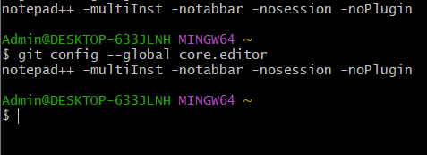

HANDS ON 2
Step 1: Open the GitDemo repository
cd ~/GitDemo

Step 2: Create a .log file

touch application.log
Step 3: Create a log folder
mkdir -p log
Step 4: Create a file inside the log folder
touch log/debug.txt
Step 5: Create the .gitignore file
notepad++ .gitignore
Step 6: Add the following rules to .gitignore
*.log
log/
Step 7: Display the .gitignore file
cat .gitignore
Step 8: Check the repository status
git status
Step 9: Display ignored files
git status --ignored
Step 10: Stage the .gitignore file
git add .gitignore
Step 11: Commit the .gitignore file
git commit -m "Add gitignore for log files and folders"
Step 12: Push to GitLab
git push origin master
Step 13: Verify the final status
git status

OUTPUTS:
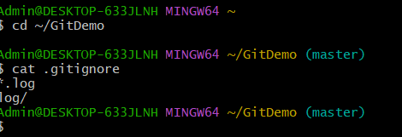
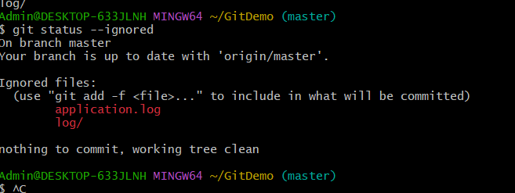
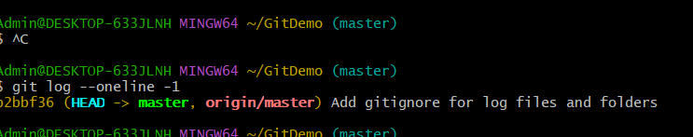

Hands-On 3:
Branching and Merging
Step 1: Open the GitDemo repository
cd ~/GitDemo
Step 2: Create a new branch
git branch GitNewBranch
Step 3: List all local and remote branches
git branch -a
Step 4: Switch to the new branch
git switch GitNewBranch
Step 5: Create a new file
notepad++ branch-file.txt
Step 6: Add content to the file
This file was created in GitNewBranch.
Save and close Notepad++.
Step 7: Add the file to the staging area
git add branch-file.txt
Step 8: Commit the changes
git commit -m "Add file in GitNewBranch"
Step 9: Check the branch status
git status
Step 10: Push the new branch to GitLab
git push -u origin GitNewBranch
Step 11: Switch back to the master branch
git switch master
Step 12: Display command-line differences between master and GitNewBranch
git diff master GitNewBranch
Step 13: Configure P4Merge as the visual difference tool
git config --global diff.tool p4merge
git config --global difftool.p4merge.path "C:/Program Files/Perforce/p4merge.exe"
git config --global difftool.prompt false
Step 14: Display visual differences using P4Merge
git difftool master GitNewBranch
Step 15: Merge GitNewBranch into master
git merge GitNewBranch
Step 16: Display the commit graph after merging
git log --oneline --graph --decorate --all
Step 17: Delete the local branch
git branch -d GitNewBranch
Step 18: Push the merged master branch to GitLab
git push origin master
Step 19: Delete the remote branch after merging
git push origin --delete GitNewBranch
Step 20: Verify the final status
git status

OUTPUTS:
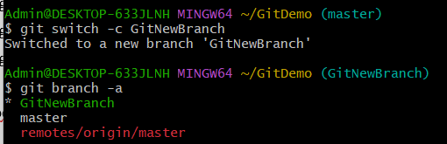
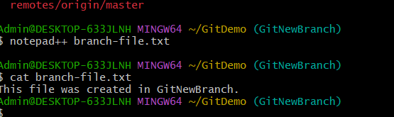
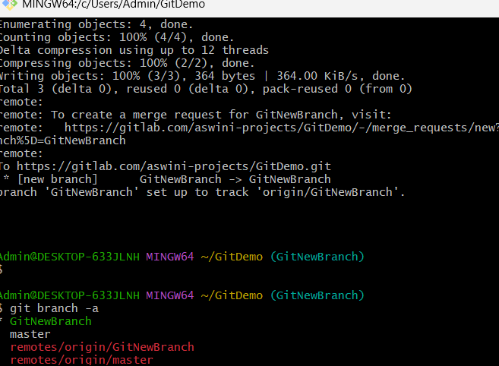
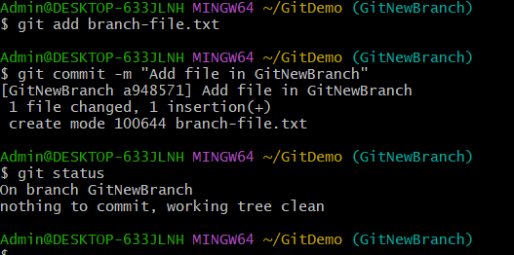

Hands-On 4:
Merge Conflict Resolution
Step 1: Open the GitDemo repository
cd ~/GitDemo
Step 2: Switch to master
git switch master
Step 3: Verify that master is clean
git status
Step 4: Create and switch to GitWork
git switch -c GitWork
Step 5: Create hello.xml
notepad++ hello.xml
Step 6: Add content in GitWork
Hello from GitWork branch
Save and close Notepad++.
Step 7: Check the status
git status
Step 8: Stage and commit hello.xml
git add hello.xml
git commit -m "Add hello.xml in GitWork"
Step 9: Switch to master
git switch master
Step 10: Create hello.xml in master
notepad++ hello.xml
Step 11: Add different content in master
Hello from master branch
Save and close Notepad++.
Step 12: Stage and commit hello.xml
git add hello.xml
git commit -m "Add hello.xml in master"
Step 13: Display the branch history
git log --oneline --graph --decorate --all
Step 14: Display command-line differences
git diff master GitWork
Step 15: Display differences using P4Merge
git difftool --tool=p4merge master GitWork
Step 16: Merge GitWork into master
git merge GitWork
Step 17: Display the conflict markers
cat hello.xml
Step 18: Resolve the conflict using P4Merge
git mergetool --tool=p4merge
Step 19: Check the resolved file
cat hello.xml
Step 20: Check the status
git status
Step 21: Stage the resolved file
git add hello.xml
Step 22: Commit the conflict resolution
git commit -m "Resolve conflict between master and GitWork"
Step 23: Open .gitignore
notepad++ .gitignore
Step 24: Add the backup-file rule
*.orig
Save and close Notepad++.
Step 25: Commit the updated .gitignore
git add .gitignore
git commit -m "Ignore merge backup files"
Step 26: List all branches
git branch -a
Step 27: Delete GitWork
git branch -d GitWork
Step 28: Display the final commit graph
git log --oneline --graph --decorate --all
Step 29: Push the changes
git push origin master
Step 30: Verify the final status
git status

OUTPUTS
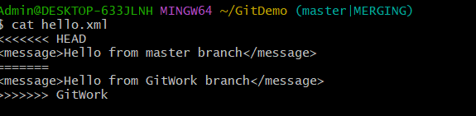
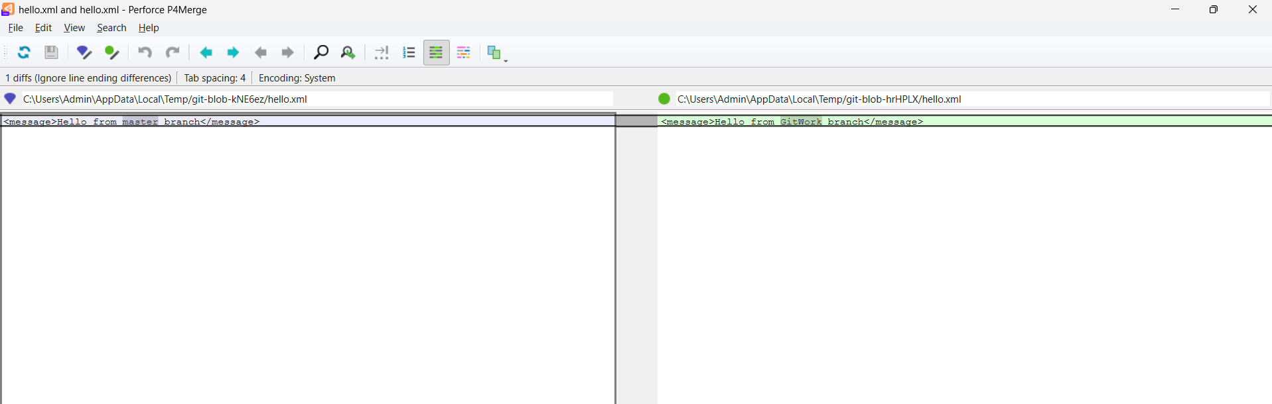
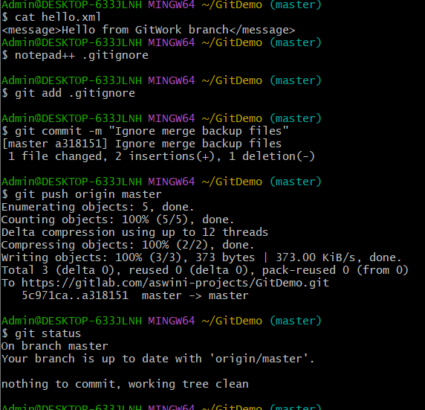
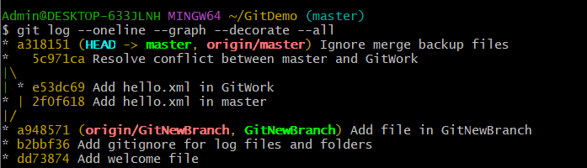
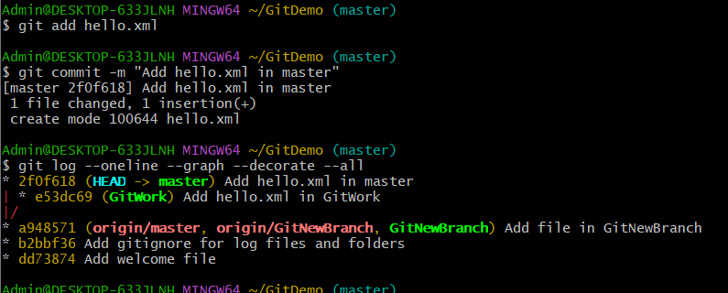

Hands-On 5:
Clean Up and Push to Remote Git
Step 1: Open the GitDemo repository
cd ~/GitDemo
Step 2: Switch to the master branch
git switch master
Step 3: Verify that master is clean
git status
Step 4: List all local and remote branches
git branch -a
Step 5: Pull the latest changes from the remote repository
git pull origin master
Step 6: Push pending changes to the remote repository
git push origin master
Step 7: Verify the final repository status
git status
Step 8: Display the final commit history
git log --oneline --graph --decorate –all
outputs
